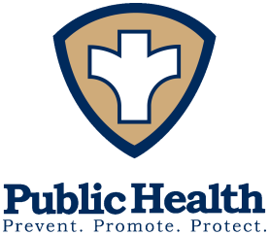
Board of Health
Pamela Riggs, MPH
Health Commissioner

Phone: (937) 498-7249
Fax: (937) 498-7013
sschd@shelbycountyhealthdept.org shelbycountyhealthdept.org

Sidney-Shelby County

Phone: (937) 498-7249
Fax: (937) 498-7013
sschd@shelbycountyhealthdept.org

202 W. Poplar Street, Sidney, OH 45365

Special Board of Health Meeting
April 1, 2024

Agenda

- Call to Order
- Adoption of Agenda
- Approval of 2025 Preliminary Budget
- Questions/Comment Re: FYI Materials
- Next Board of Health Meeting –April 17, 2024 at 7:00 p.m.
Adjournment

