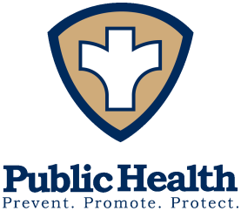*Board of Health*

Pamela Riggs, MPH

Health Commissioner

Phone: (937) 498-7249

Fax: (937) 498-7013

[sschd@shelbycountyhealthdept.org](mailto:sschd@shelbycountyhealthdept.org) [shelbycountyhealthdept.org](mailto:sschd@gw.odh.state.oh.us)

*Sidney-Shelby County*

Phone: (937) 498-7249

Fax: (937) 498-7013

[sschd@shelbycountyhealthdept.org](mailto:sschd@shelbycountyhealthdept.org)

202 W. Poplar Street, Sidney, OH 45365

Board of Health Meeting

March 19, 2025

**Revised Agenda**

1. Call to Order
2. Adoption of Agenda
3. Approval of February 19, 2025 Meeting Minutes
4. Environmental Health Report
   1. EH Updates
5. 2026 Preliminary Budget
6. Approval of Bills
   1. February 2025
7. Financial Report
   1. February 2025
8. Public Health Nursing Division
   1. Monthly Report
   2. Disease Report
9. Questions/Comment Re: FYI Materials
10. Next Board of Health Meeting –April 16, 2025 at 7:00 p.m.
11. Adjournment