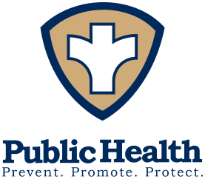
Board of Health
Pamela Riggs, MPH
Health Commissioner

Phone: (937) 498-7249
Fax: (937) 498-7013
sschd@shelbycountyhealthdept.org shelbycountyhealthdept.org

Sidney-Shelby County

Phone: (937) 498-7249
Fax: (937) 498-7013
sschd@shelbycountyhealthdept.org

202 W. Poplar Street, Sidney, OH 45365

Date: March 11, 2026

To: Sidney-Shelby County Board of Health

From: Erica Lentz, MSN, RN, Health Commissioner

RE: Board of Health Meeting
March 18, 2026 – 7:00 p.m. – Health Department

Please call if you are not planning to attend.

Tentative Agenda

- Call to Order
- Adoption of Agenda
- Approval of February 18, 2026 Meeting Minutes
- Environmental Health Report
  - Jennifer Bowersock, Jenn’s Backstube- Food Equipment Policy Variance Request
  - Jessica Loveland, 4021 Russia-Houston Rd., Houston – Condemnation Order
  - Resolution 26-3 Water Pollution Control Loan Fund Agreement
  - EH Updates
- Approval of Bills
  - February 2026
- Financial Report
  - 2027 Preliminary Budget
  - February 26, 2026 Letter to the Auditor
- Public Health Nursing Division
  - Monthly Report
  - Disease Report
  - Employment of Christine Schmerge
- Questions/Comment Re: FYI Materials
- Next Board of Health Meeting – April 15, 2026 at 7:00 p.m.
- Adjournment

